OTHERWISE EDUCATION

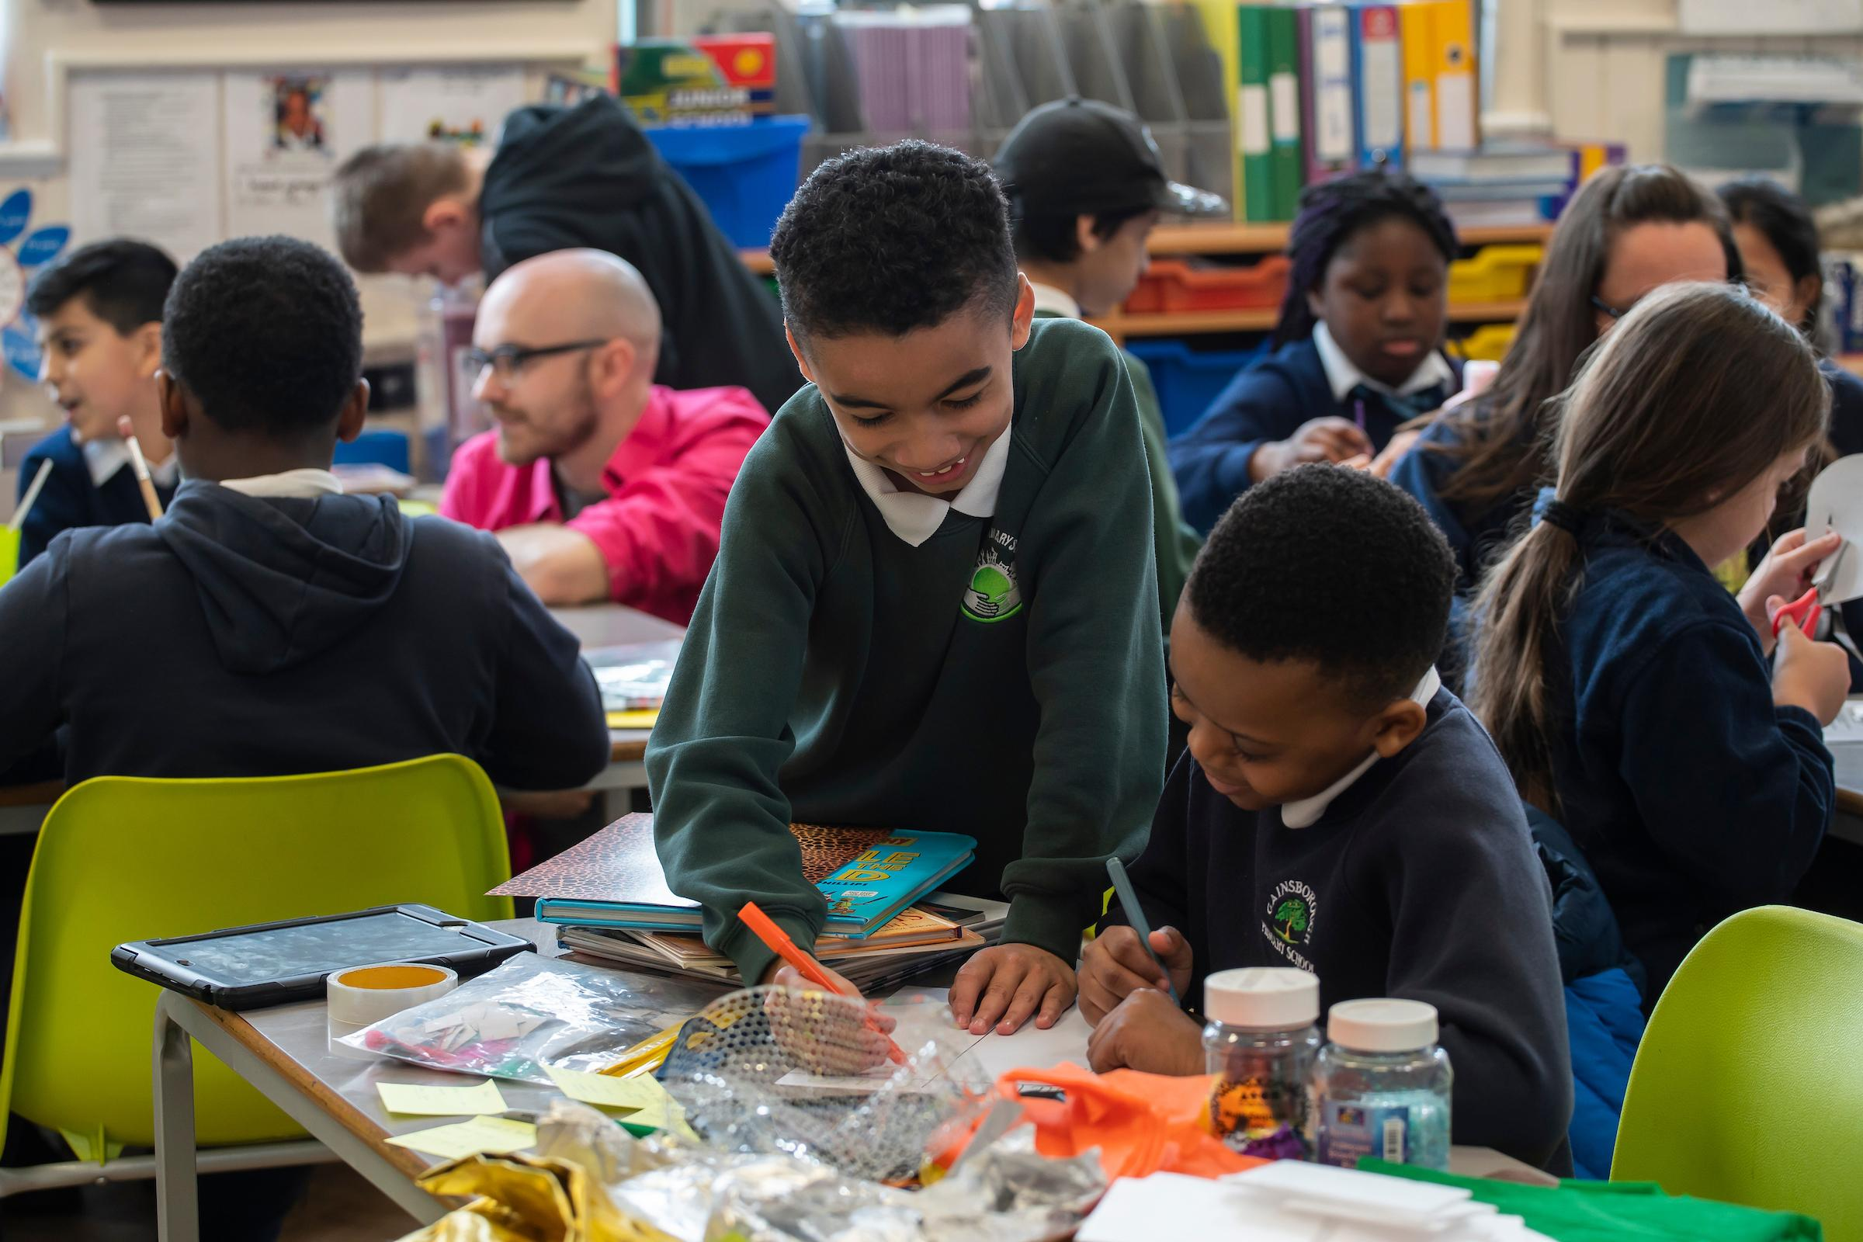
Photo credit: Andrew Baker Photographer

ABOUT OTHERWISE

Otherwise Education is a small creative learning consultancy which specialises in supporting schools to provide innovative, memorable and collaborative learning projects, and CPD which support children’s writing, self-confidence and emotional resilience.

Otherwise links up the work of Jonny Walker, a teacher and former Assistant Head; Jo Castro, a coach and experienced teacher; and Adisa the Verbalizer, a performance poet in education.

We run innovative and ambitious learning projects with students which encourage them to think deeply, challenge themselves, collaborate and form friendships across schools.

We also work with schools and arts organisations to support staff development, through sessions that we have designed as well as through bespoke commissions and consultancy.

OTHERWISE LEARNING PROJECTS

Writes of Passage

‘Writes of Passage’ brings together a small number of pupils and a staff member from local schools to form a large active, ambitious writing network. The project is grounded in research into the importance of developing ‘writing for pleasure’ pedagogies, to support children’s capabilities as skilled writers.
Sessions are led by Jonny Walker and Jo Castro.
- Six whole-day workshops across the academic year, plus a published anthology
- Teacher development and guidance to support learning back at school

Cost - £600 per school per year – 12 schools take part in each cohort
In 19-20, the first Writes of Passage Primary (Y5) cohort is running at Stratford Circus.

The Iliad Project

An immersive and challenging Year 5 – 8 project which introduces pupils to Homer’s ‘The Iliad’, and guides them to engage with philosophical enquiry, art appreciation, text analysis and dramatic interpretation.
The project involves four days of in-school facilitation, plus a visit to the University of Cambridge.
The project works well if several schools collaborate to run it together.

Maximum of 30 pupils.
Cost - £2,250 plus VAT + coach hire to Cambridge

Poetry Retreat Project

The Poetry Retreat Project provides pupils (and staff) with a transformative opportunity to write, reflect and find themselves over the course of a four-day visit to a site of outstanding natural beauty, such as the New Forest. Schools collaborate, allowing pupils and staff to learn together. Children produce an anthology, and run a recital for parents upon our return.
The project is led by Jonny and Adisa the Verbalizer.
As well as our three years running the Y5/6 project with Elmhurst Teaching School Alliance, we are keen to run retreats with secondary schools.
Cost - £4,050 + YHA Hire + Coach Hire – c. £8500, split between schools)

CPD, Consultancy and Bespoke Support

Jonny, Jo and Adisa are available to lead primary CPD around the teaching of English:
e.g. reading, analysing and writing poetry; reading for pleasure; writing for clarity; grammar;
speechmaking and oracy; playscripts and performance.
Cost - £200 for 1-2 hours CPD / £300 for co-facilitated for 1-2 hours CPD

We welcome schools to approach us for bespoke support around poetry, literacy and creative writing;
eg Adisa and Jonny are working with a school to develop their whole-school culture of poetry through developing a canon, leading CPD, running workshops with pupils and running a Festival of Poetry.

Daily rates - £250 for half day / £450 for a full day

